FIELD REFERENCES
Position Description
Reason:  - Select the reason that best applies for editing or creating the PD. |  | 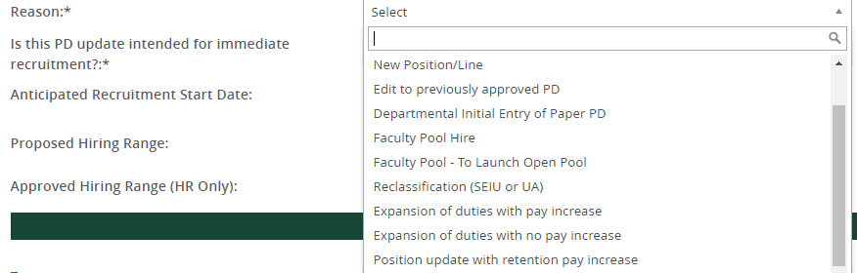
Recruitment information:  - Select if PD is intended for immediate recruitment (shortly following approvals).  - Select if PD is intended for a direct appointment.  - If PD is for recruitment and a proposed hiring range is known, enter that range.  - The Approved Hiring Range (HR Only) field will be completed by HR for OA positions. |  | 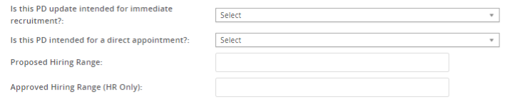
General Position Information
Team:
- Populated based on user completing PD
Position Title:
- This is the title that will display on the job posting and be the working title for the position.

Position Classification:  - Populated once the job is created in Banner.  - If the position exists in Banner, the blue box displays key information about the position classification.  Position Number:  - Populated once the job is created in Banner.  - If the position exists in Banner, the blue box displays key information about the position. |  | 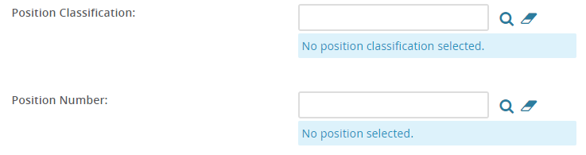
Org Structure:  - Select the appropriate VP Area, School/College/Admin Unit, Division/Admin Sub Unit, and Department or Program. The first two org levels are required, the second two are optional. | 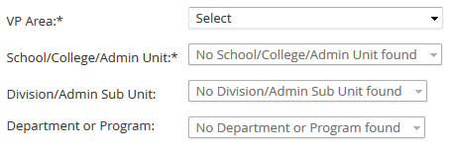
Timesheet Org:  - Enter the timesheet org for the position.  - You can search the library of timesheet orgs by clicking the magnifying glass icon.  - Searches can be conducted by either org code or the Cost Center (department) name.  - The org code can be viewed in numerical order or alphabetically by cost center name.  - Putting a partial code or name in the search fields will bring back multiple possible results. |  | 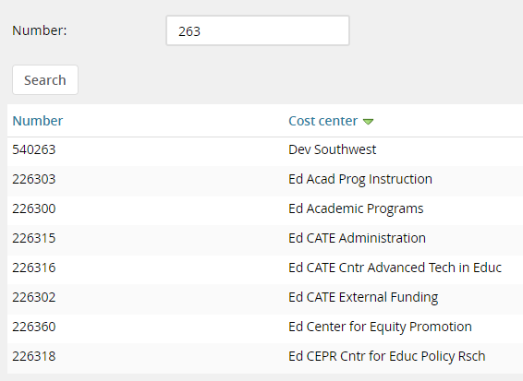
Type of Position:  - Select the type of position.  - The position type will be finalized by Human Resources when the Position Description is approved. |  | 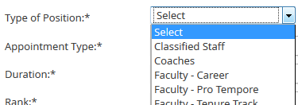
Appointment Type:  - Select the Appointment Type from the available choices.  - Note that some appointment types are specific to certain employee groups. |  | 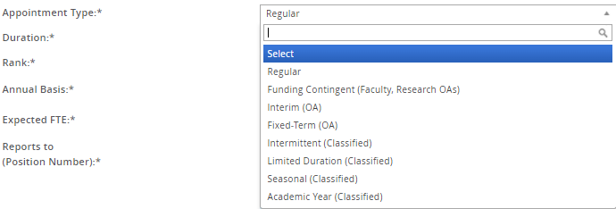
Duration:  - Select the Duration you expect for this position. |  | 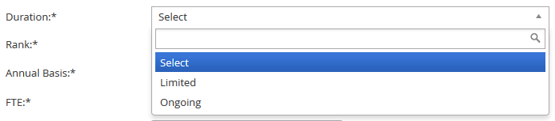
Rank:  - Select the Rank for this position.  - All non-faculty positions, select No Rank.  - For faculty positions with multiple ranks, select the lowest rank possible for the position.  - You will confirm the rank for the successful candidate at the point of hire. |  | 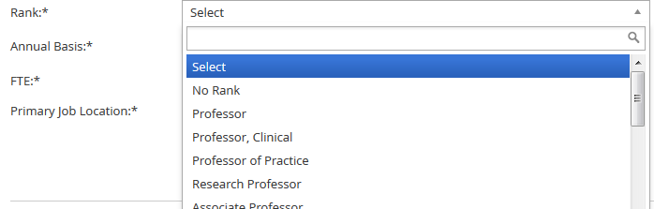
Annual Basis:  - Select the Annual Basis for the position. |  | 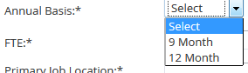
Expected FTE:
- Enter the expected FTE for the position.
- Enter a number between 0.01 and 1.0.

Reports to (Position Number):
- Enter the position number (B#) of the position that this position reports to.
- You may use the magnifying icon to open the search window.
- HR recommends using Banner PWIVERI if you are having difficulty finding the B# of the supervisor.

Primary Job Location:
- Enter the primary location for the job. Click on the binoculars to search by Site No. or Site Name.
- The primary location choices come from Banner.
- The table is organized by city in Oregon, State in the U.S., British Columbia, and Outside US for all other international locations.

POSITION BUDGET
Position Funding:  - Select the funding source for this position.  - If the funding is not yet final, select requested appropriate. | 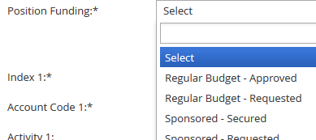
Labor Distribution:
- This section provides information about the initial labor distribution for the position.
- Please give the primary labor distribution for this position by listing index, account code, and percentage.
- For full FOAPAL elements or a split labor distribution, use the “Explanation” field to list additional items (such as another index, or a specific activity code).

Position Details
Organizational Chart:  - Upload an org chart by clicking on Documents tab at the top of the PD.  - From the drop down menu, select “Document from File.”  - Select Org Chart as the Document Category.  - Title your Org Chart (optional)  - Click “Upload file” to browse for the file and select the file you would like to upload.  - Click “save and close” to return to the Position Info tab to complete your Position Description. | 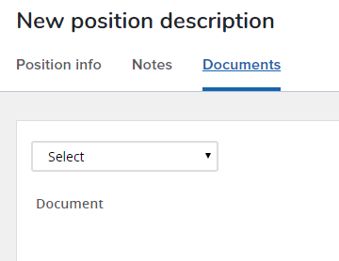  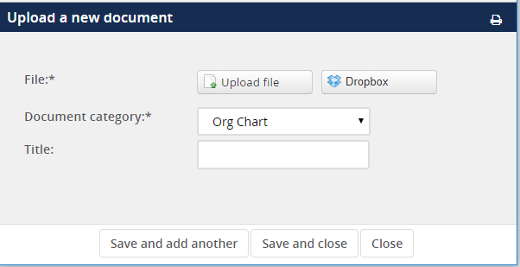
Position Summaries and Qualifications
- Each of these sections should be filled out completely.
- These fields will also be used to build out the job advertisement.
- For guidance on how to write summaries and define qualifications, please see our PD Guidance and other resource materials.

Supervision
Supervisory Responsibilities:  - Select the level of supervisory responsibilities this position has. For full definitions, see our PD Guidelines.  - If multiple selections apply, pick the highest level regularly performed. | 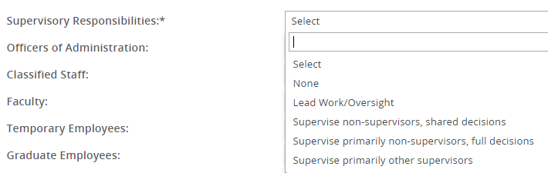
Employee Count:  - Indicate in the fields the amount of FTE for each type of employees this position has supervisory responsibilities for. | 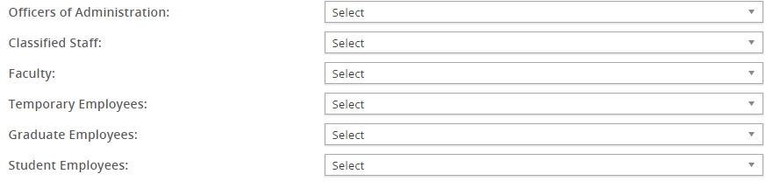
Decision Making & Fiscal Responsibility
Scope of Decisions Made  - Select the appropriate choice from the drop down menu that covers the scope of decisions that this position makes  - Full definitions of menu items are available in PD Guidelines | 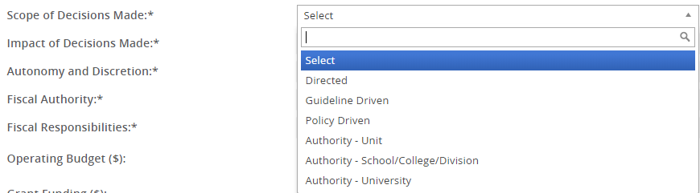
Impact of Decisions Made  - Select the appropriate choice from the drop down menu that covers the impact of decisions that this position makes  - Full definitions of menu items are available in PD Guidelines | 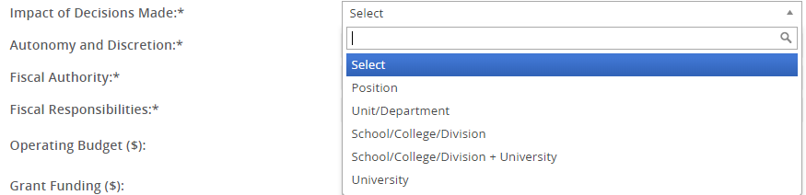
Autonomy and Discretion  - Select the appropriate choice from the drop down menu that covers the level of autonomy and discretion for this position.  - Full definitions of menu items are available in PD Guidelines | 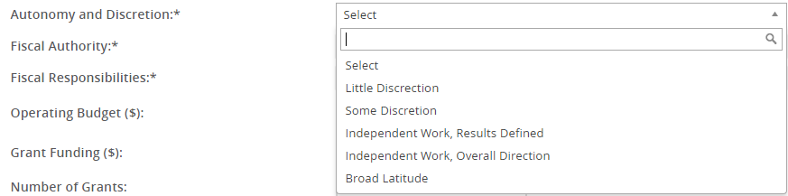
Fiscal Authority  - Select the appropriate choice from the drop down menu that covers the fiscal authority (scope of influence) for this position.  - Full definitions of menu items are available in PD Guidelines | 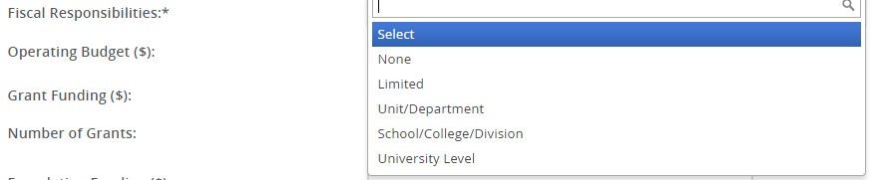
Fiscal Responsibilities  - Select the appropriate choice from the drop down menu that covers the fiscal responsibilities within the defined scope for this position.  - Full definitions of menu items are available in PD Guidelines | 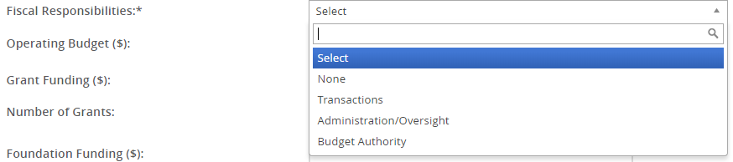
Budget Fields
- If the position has fiscal authority or responsibilities, enter the total operating budget. Depending on the position, this could include General, Auxiliary, Grant, Foundation, and/or Agency funds
- Grant funding, number of grants, foundation funds, number of foundation funds, and agency funding are optional fields
- Fields labeled with ($) should be dollar amounts, rounded as reasonable
- Only list budget that the position has fiscal authority or responsibilities for.
Job Duties
Job Duties:  - To enter a job duty, click “new.”  - Enter the percentage of time, duties/responsibilities, and then select whether the duty is essential or incidental.  - Click add to save the entered information under Job Duties.  - You must click add after every duty. Confirm duties are complete and add to 100%. | 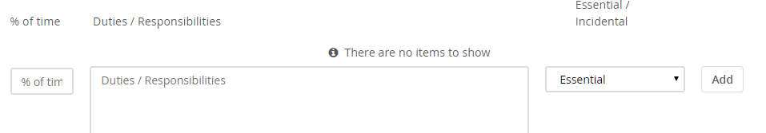
Working Conditions
Typical Work Functions  - Check any applicable typical work functions. | 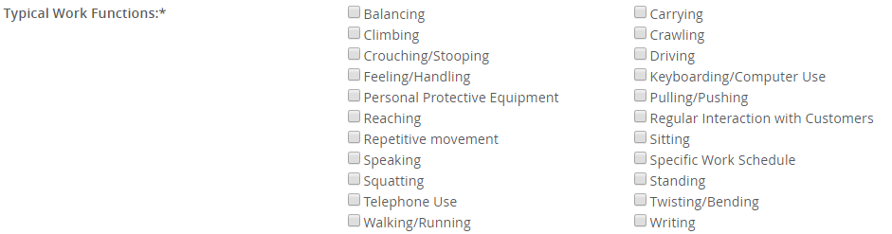
Typical Working Environment and Hazards  - Check any applicable typical working environment conditions or hazards.  - “Normal Office Environment” is available for positons that work in a standard office. | 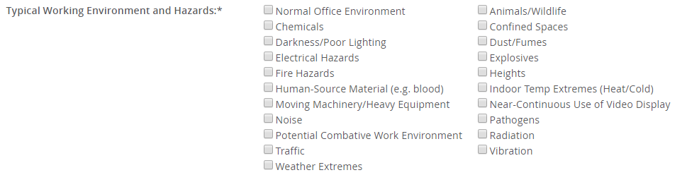
Lifting Demands:  - Enter the lifting demands for this position.  - Minimum lifting demands are 10 pounds. | 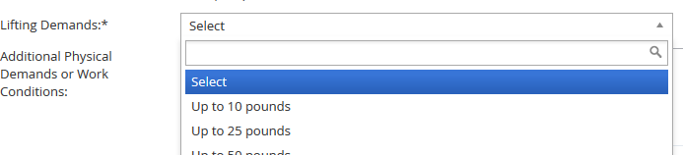
Additional Physical Demands or Work Conditions:
- Enter any additional physical demands or work conditions not covered by the selections above.
Frequency of Travel:  - Enter the percentage of time this position may be required to travel.  - Minimum travel frequency is “up to 10%.” | 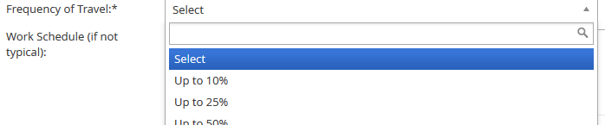
Work Schedule (if not typical or specified):
- Enter the work schedule if not typical. Typical schedule is defined as 8 a.m. to 5 p.m.
- If a specific schedule is required as a part of job duties, please note that here.
- A flexible work agreement may be required and can be uploaded to the system at the point of offer.
HUMAN RESOURCES
Export:  - This field is used by HR for data exports related to PD data.  Budget Profile  - This section is completed by HR  Coding  - This section is completed by HR  Salary, Bargaining Unit, & FLSA Status:  - Completed by HR as a part of PD Review  - The salary range displays the approved salary range or comp band for the position.  - The range/band is visible in the blue box.  - HR recommends review of this section after approval  Background Checks:  - Completed by HR as a part of PD review.  - All positions require a criminal background check.  - Additional required checks will be selected as part of the position review. | 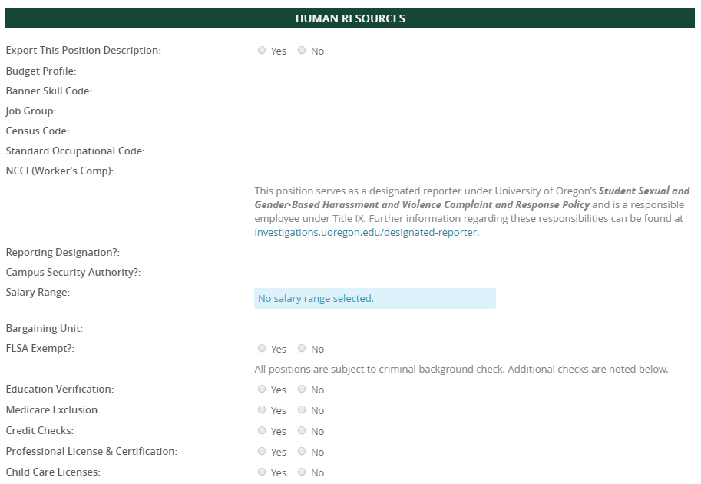
USERS
User Fields  - Enter your unit’s HR Administrator, the Hiring Manager for the position, and the Unit Director/Head in these fields.  - The Unit Director/Head field is located below the approval process section.  - The Hiring Manager field will auto-fill to the person who began creating the Position Description. This can be updated if needed.  - You can either type the name of the appropriate individual in the box, or click on the magnifying glass icon to search for the appropriate individual.  - Users in these three roles will receive an email once the PD is updated. | 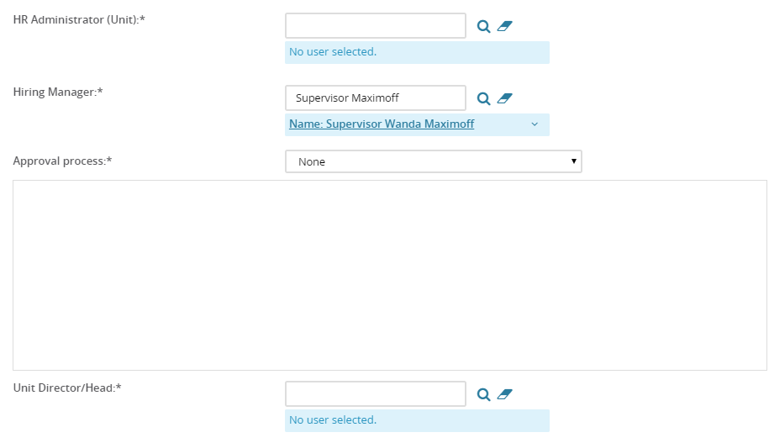

USERS
Approval Process:  - Select the appropriate approval process.  - Use the Special Review Required position if the position requires approval of a special reviewer or secondary unit prior to being submitted to Human Resources.  - Enter appropriate approvers into the approval roles.  - The system will remember past approvers, but you may adjust these as needed. Do not adjust HR reviewer roles. | 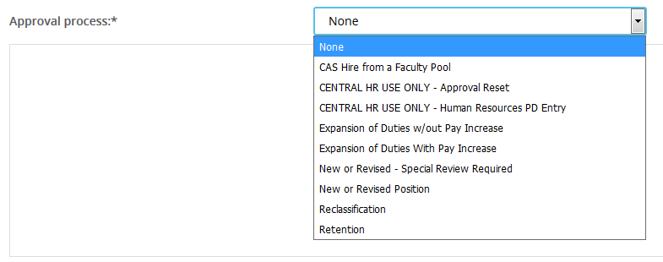

Complete the Job Description
Saving the Position Description
- Save a draft can be used when you need to save the PD you are working on without starting the approval process. HR recommends saving your work at least every hour.
- Submit will save and launch the approval process that was set on your position description. You will remain in the PD.
- Submit and exit will save and launch the approval process that was set on your position description and exit your screen back to the home screen.
- Cancel will exit the position description without saving.
Notes Tab  - You can add notes about the position description using the notes tab.  - From the drop down field, select “note” and add your note.  - Notes can be emailed directly to users.  - You can attach files to your notes.  - Notes remain visible on the position description to anyone who can access the position description. Notes are retained through subsequent approval processes. | 