Oregon Veterans’ Preference Legislation:
Hiring Process Implementation
(Revised July 2018)

The State of Oregon has several pieces of legislation related to Advantages Given Veterans in Public Employment (Oregon Revised Statutes 408.225 – 408.290). Statutes 408.230, Veterans’ Preference in Public Employment, 408.235 Eligibility for Preference, and 408.237, Interviews of Veteran Applicants for Public Service Position Required, relate specifically to the hiring process and require that, under certain circumstances, veterans be given a preference and be interviewed.
Below is a review of the applicable statutes and a brief summary of the key aspects of the hiring process that are most impacted by the Oregon Veterans’ Preference legislation. Following this are implementation guidelines specific to the university’s hiring process.

Overview of Statutes
- ORS 408.230 Veterans’ Preference in Public Employment
Public employers must grant a 5% preference to veterans or a 10% preference to disabled veterans who apply for civil service positions and meet the minimum qualifications and any special qualifications for the positions.
- ORS 408.235 Eligibility for Preference
A veteran is eligible to use the preference for civil service positions for which application is made at any time after discharge or release from service in the Armed Forces.
- ORS 408.237 Interviews of Veteran Applicants for Public Service Position Required
When an interview is part of the selection process for a civil service position, a public employer shall interview each veteran who meets the minimum and special qualifications for the position and submits application materials that show sufficient evidence that the veteran has the transferable skills requested and required by the employer.

Applicable Definitions
  - Civil Service Position (ORS 408.225): any position for which a hiring or promotion decision is made based on the results of a merit based, competitive process that includes, but is not limited to, consideration of an applicant’s or employee’s relative ability, knowledge, experience and other skills (need not be labeled a “civil service position”).
  - Special Qualifications (not specifically defined as applied to this statute, but the Bureau of Labor and Industries (BOLI) uses the definition from OAR 105-040-0030): qualifications added to minimum qualifications and necessary (required) at the time of appointment based on the duties of the position to be filled. They may include, but are not limited to, bilingual skills, licenses, permits, and/or certifications required by law.
Please note the distinction between special qualifications (required) and preferred qualifications (desired but not required).

  - Transferable Skills (OAR 839-006-0440): skills that a veteran has obtained through military education or experience that relate, directly or indirectly, to the civil service position for which the veteran is applying.
The American Council on Education website http://www.acenet.edu/news- room/Pages/Military-Guide-Online.aspx provides a tool employers can use for assessing how military training and experience translate to the civilian job market. The Oregon Department of Veterans’ Affairs www.oregon.gov/ODVA (503-373-2000) and the Oregon Military Department www.oregon.gov/OMD (503-584-3980) also provide services for determining whether military education or experience produces a transferable skill.

Summary
This summary highlights the basic steps necessary to implement the Oregon Veterans’ Preference regulations and does not attempt to address all possible selection process procedures. More specific information is included in the Implementation Guidelines which follow.
- Identify veterans or disabled veterans eligible for preference based on applicant flags in MyTrack set by Human Resources. (See Identification of Veterans below)
- Review all application materials to ascertain whether candidates, including veterans, meet stated minimum and special qualifications. Applicants whose applications do not show evidence of meeting stated minimum requirements require no further review. (See Application Review: Minimum and special qualifications below)
- Evaluate application materials from remaining candidates to determine the extent to which each applicant meets preferred qualifications and shows evidence of job-related knowledge, skills and experience. Continue to consider potential transferable education or experience that candidates, including veterans, would bring to the position. Apply the appropriate Veterans’ Preference as follows:
  - If using a scored evaluation tool, provide a 5% preference for veterans or 10% preference for disabled veterans.
  - If using a non-scored evaluation tool, provide special consideration for veterans and disabled veterans equivalent to a 5% or 10% preference.
(See Application Review: Continued assessment of qualifications below)
- If there are veterans who meet minimum and special qualifications but are not among top candidates after evaluation of all candidates is complete and Veterans’ Preference has been applied, decide whether to conduct a preliminary interview or to advance them to the phone and/or campus initial interview. (See Interviews below)
- If conducting a preliminary interview, use this interview to ascertain whether the veteran candidate has transferable knowledge or skills from his or her military experience that would change your overall assessment sufficiently to advance them into the top group of candidates. (See Interviews: Preliminary Interview for Veterans below).

- Conduct interviews with top candidates, including any veterans whose rankings, with preference, are among the top group, and any veterans for whom preliminary interviews about transferable skills resulted in placement among the top group of candidates.
- Identify top candidates for ongoing consideration and conduct campus visits, reference checks and all remaining steps in the search process, ensuring that the preference for any covered veteran is ongoing throughout the process. (See Interviews and Selection Following Interviews below)

Implementation Guidelines

Position Announcements
Both minimum qualifications and special qualifications should be clearly identified in the position announcement. Special qualifications are most frequently applicable in searches for classified positions, where a particular position requires qualifications beyond those listed in the classification specification. As with minimum qualifications, care should be taken to ensure that anything identified as a special qualification is a qualification that a candidate must have in order to successfully perform the duties of the position, as opposed to preferred qualifications which are desired but not required. Human Resources works closely with units in identifying minimum and special qualifications in the development of the position description.

Identification of Veterans
For all positions accepting applications via MyTrack, the University's online applicant tracking system, applicants will be asked as a part of the application process if they identify as a veteran under Oregon law. Applicants who identify are asked to submit documentation of their eligibility directly to Human Resources, who verifies the applicant's eligibility and places a "flag" on their application.

HR administrators on the search or hiring managers will identify veterans or disabled veterans eligible for preference based on the indicator flags in the MyTrack listing of applicants. To navigate to the listing that shows flags, select "Manage Requisitions" under the expandable ("hamburger") menu in the upper right-hand corner of MyTrack; please note that this is the only area where indicator flags will show. The area where selection outcomes for applicants are designated does not display the indicator flags.
Indicator flags will show veterans who have submitted necessary documentation of eligibility and whether the veteran is entitled to receive 5% preference or 10% preference (for disabled veterans) during selection process. Status indicators will show if the candidate has self-identified but is still awaiting documentation submission or HR review. HR administrators should review the candidate pool and ensure the search chair or search committee is prepared to provide veterans' preference prior to beginning candidate review.

Only applicants flagged by Human Resources should be given preference, even if there are indicators of military experience in the materials of an applicant without a flag.

Selection Steps

Application Review
  - Minimum and special qualifications: The selection process should first determine, as much as possible from the written application, if candidates meet identified minimum and special qualifications. All information supplied by applicants should be considered during the assessment for minimum qualifications. If a veteran candidate does not specifically address the issue of transferable skills, then the search committee can consider, as with other candidates, that the information in the application materials addresses all relevant skills and training, and make a determination on the basis of those materials as to whether the candidate meets the stated minimum qualifications. No veterans’ preference is applied at this stage of the review.
  - Candidates who clearly do not meet minimum and special qualifications, regardless of veteran status, require no further review. The committee will need to document how the applicant did not meet minimum or special qualifications.
  - Any veteran or disabled veteran who possesses both the minimum and special qualifications must be given the opportunity for an interview. See “Interviews” below for additional information.
  - Continued assessment of candidates who meet minimum and special qualifications: The evaluation of candidate capabilities beyond the required minimum and special qualifications may be either a scored or non-scored process, but should continue to consider potential transferable education or experiences and must include application of the veteran’s preference.
    - Scored selection process: identified veteran and disabled veteran candidates eligible for preference should be awarded an additional 5 (veteran) or 10 (disabled veteran) percentage points of the total possible points in calculating their scores. For example:
      - If using a scored tool with a total of 60 possible points, a veteran will receive an additional 3 points (5% of total possible points) and a disabled veteran will receive an additional 6 points (10% of total possible points). It is recommended that the preference be applied to either the total combined or total average score and not to individual reviewer scores. If possible, preference should be applied by one individual to ensure it is applied consistently.
        - Total combined score method: If 3 people are scoring using a tool with 60 possible points and the combined scores are used to rank the applicants, then there is a total of 180 possible points and a veteran will receive an additional 9 points and a disabled veteran will receive 18 additional points; or
        - Total average score method: If, out of 60 possible points, the results of 3 scorers are 40, 35, and 30, the average score is 35. Again, because there is a total possible score of 60, the veteran will receive 3 additional points and the disabled veteran will receive 6 additional points.
      - Advance any veteran whose score, with or without the preference, is at least equal to that of other candidates being advanced.
    - Non-scored selection process: develop a methodology that ensures “special consideration” of veterans and disabled veterans. While not defined in the legislation, this will generally mean giving case-by case consideration to veteran or disabled veteran qualifications to assess whether they are roughly equivalent to the qualifications of those being advanced – “roughly” meaning within about 5% (for veterans) or about 10% (for disabled veterans). One method of giving “special consideration” is to categorize, rank or rate applicants and then consider whether a 5% or 10% preference would move the qualified veteran up into the next category, rank or rating. Advance any veteran or disabled veteran who, with or without special consideration, is at approximately the same relative level as other candidates being advanced.
Example of categorizing:
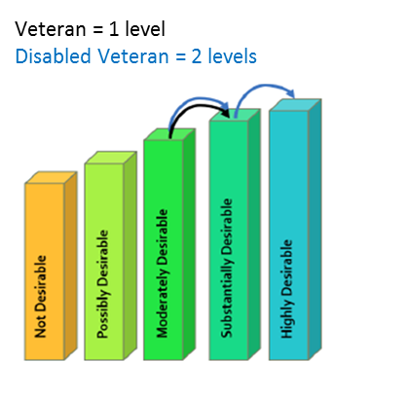
Example of ranking:
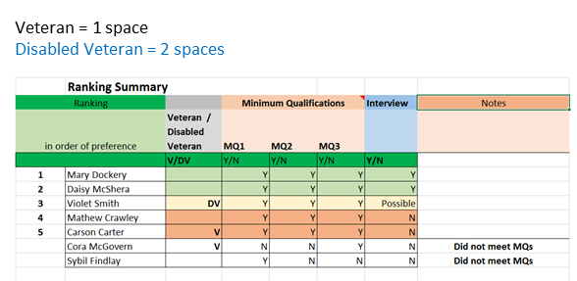
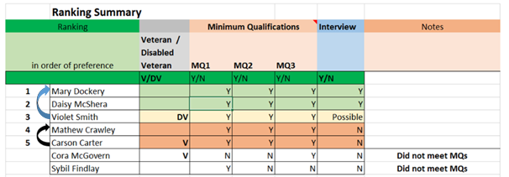
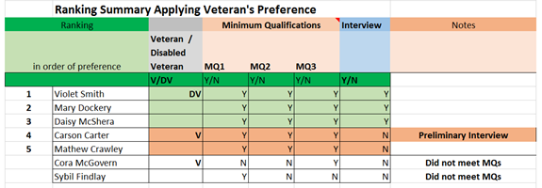

Note: When an applicant pool has both veterans and disabled veterans, the disabled veterans must be moved up the list at least twice the number of spaces as the other veterans.
Please contact Talent Acquisition in Human Resources (talent@uoregon.edu) if there are questions as to whether a proposed approach to “special consideration” is adequate to meet our legal obligations.

  - Additional assessments prior to interviews: The regulations stipulate that the Veterans’ Preference is to be applied at each stage or step of the application process. If, after the scored or non-scored assessment described above, additional steps are taken prior to determining which candidates will be offered a phone and/or campus interview, veterans’ preference must be applied for eligible veterans at each of those steps. Additional steps in the process might include an evaluation of supplemental questions or portfolio materials separate from the initial assessment or a committee deliberation after the initial assessment to allow consideration of divergent perspectives.
    - Advance any veteran or disabled veteran who, with or without application of the veterans’ preference, is at approximately the same relative level as other candidates being advanced.

Interviews
  - Each veteran or disabled veteran who applies to a competitive search at the University of Oregon for which an interview is part of the selection process must be interviewed if they meet the stated minimum and special qualifications and provide evidence of transferable skills that satisfy the position requirements. This is the case even if application of the required 5% or 10% preference or special consideration does not place the eligible veteran among the top candidates.
  - The regulations regarding the interview requirement do not say what type of interview is required. Based on discussion with the Bureau of Labor and Industries, several options are available:
  - Preliminary Interview for Veterans – this brief screening interview (phone or video) would focus on veterans who would not otherwise have been interviewed, but who meet the minimum and special qualifications and who may have transferable skills. The purpose of the interview is to give veterans the opportunity to explain how knowledge, skills, and experience acquired through military service are relevant to the position for which they have applied and to ensure that these unique skills and experiences are carefully considered in the search process. This interview would take place after the review of application materials and committee discussion, but before the traditional interviews planned by the search committee.
    - Use information acquired during this interview to reassess the results of the review of application materials and committee discussion of the candidates. This reassessment, including application of the veterans’ preference, may result in raising the candidate’s ranking, making them eligible for the next step in the process.
    - If, after reassessment of the veteran’s qualifications based on the preliminary interview and application of the 5% or 10% veterans’ preference or special consideration, the veteran is not at the same relative level as other candidates being advanced, no further review is required.
    - Search committees or hiring managers should document the results of all preliminary interviews and clearly show the reasoning why candidates do or do not advance.
  - Inclusive Preliminary Interview – This brief preliminary interview format (as described above) could be used for all candidates being considered for a phone interview as well as veterans not otherwise being considered. In addition to determining the relevance of any transferable military education and skills, questions might be aimed at determining the relevance of other applicants’ skills, thus determining early whether a candidate possesses the required knowledge, skills, and experience necessary to be successful in the position.
    - This strategy can be particularly useful if there are large numbers of well-qualified applicants and the search committee is having a difficult time narrowing down the interview pool. It also provides an opportunity to reiterate realities of the search such as salary range, rank or level of position, travel requirements or weekend work, willingness to relocate, full-time or part-time status, etc., to make sure that the applicant remains interested in the position.
  - Phone or On-Campus Interviews without a Preliminary Interview – Committees may conduct phone interviews or on-campus interviews in accordance with the normal search process, but include any eligible veterans or disabled veterans in your pool who meet the minimum and special qualifications and who may have transferable skills, even if they are not among your top candidates.
    - If, after reassessment of the veteran’s qualifications based on the interview and application of the 5% or 10% veterans’ preference or special consideration, the veteran is not at the same relative level as other candidates being advanced, no further review is required. The committee must clearly document the results of these interviews if the veterans do not advance after this stage.
  - Whatever option is chosen with regard to implementing the interview requirement for eligible veterans, it is important to keep in mind that the 5% or 10% veterans’ preference or special consideration must still be applied at each step of the process.

- Selection following interviews: The final selection decision should be based on the application review and interviews, with the veterans’ preference again applied for any veteran or disabled veteran candidates after the final interviews and deliberation. The Oregon Veterans Preference in Employment legislation does not require that a public employer appoint a veteran to the open civil service position. However, if a veteran’s or disabled veteran’s score, rank, rating or other qualitative assessment, with required preference, is equal to or higher than the results for a non-veteran applicant, then the veteran or disabled veteran shall be appointed.

Documentation
  - The legislation requires that if a public employer does not appoint a veteran or disabled veteran to a vacant position, the employer shall, upon written request of the veteran or disabled veteran, provide in writing the employers’ reasons for the decision not to appoint the veteran or disabled veteran to the position. The decision not to appoint the veteran or disabled veteran may be based solely on the veteran’s or disabled veteran’s merits or qualifications with respect to the position.
  - Documentation of interviews, results, and decisions not to appoint the veteran or disabled veteran applicants can be uploaded to the "Notes" or "Documents" tab on the job requisition in MyTrack by either the Hiring Manger or the HR Administrator.
  - For guidance on unique situations not covered in this guidance or for assistance in determining appropriate documentation and recording search results, please consult with Talent Acquisition in Human Resources. Additional information can be found on the Veterans Preference section of the Human Resources website: http://hr.uoregon.edu/recruitment/oregon-veterans-preference-employment

