MyTrack Position Description
Field references

Position description
Reason  - Select the reason that best applies for editing or creating the position description (PD). | 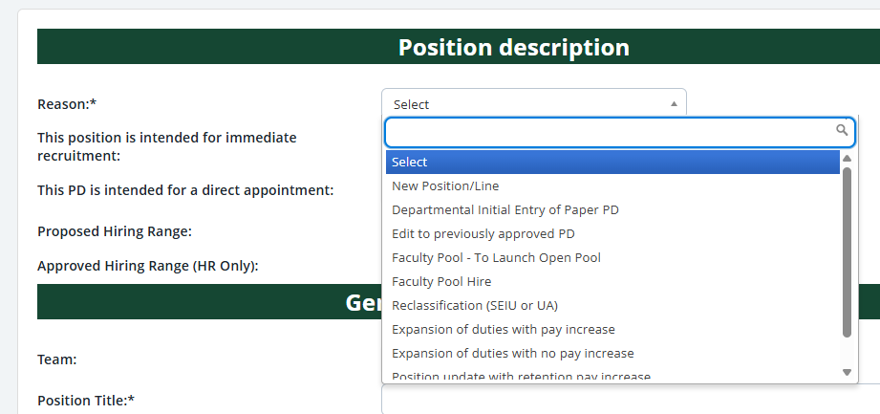
Recruitment information  - Indicate if the PD is intended for immediate recruitment (shortly following approvals).  - Indicate if the PD is intended for a direct appointment.  - If the PD is for a recruitment, and a proposed hiring range is known, enter that range.  - The “Approved Hiring Range (HR Only)” field will be completed by University Human Resources (UHR) for OA positions. | 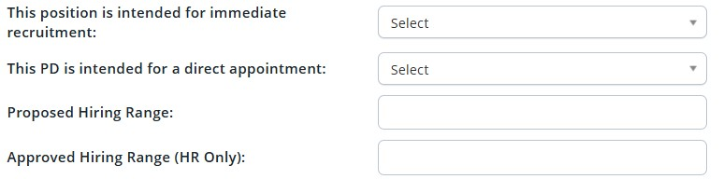
1

General position information
Team  - This will default to the primary team of the user who launched the PD.  - If you have secondary teams assigned, you will have the option to reassign the PD team until it is approved. After the PD has been approved, you will need to contact your Recruitment Consultant to have the team change.  Position Title  This is the title that will be displayed on the job posting and be the working title for the position. | 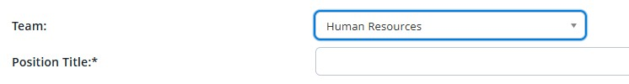
Position Classification  - Populated once the job is created in Banner.  - If the position exists in Banner, the blue box will display key information about the position classification.  Position Number  - Populated once the job is created in Banner.  - If the position exists in Banner, the blue box displays key information about the position. | 
Org Structure  - Select the appropriate VP Area, School/College/Admin Unit, Division/Admin Sub Unit, and Department or program. The first two org levels are required, the rest are optional. | 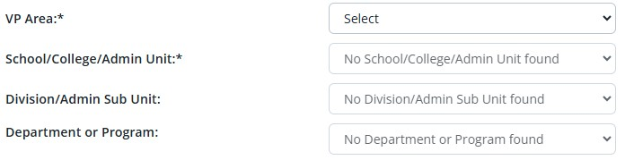

Timesheet Org •  Enter the timesheet org for the position.  - You can search the library of timesheet orgs by clicking the magnifying glass icon.  - Searches can be conducted by either Number (org code) or Cost center (department name).  - Entering a partial code or name will return all partial matches. | 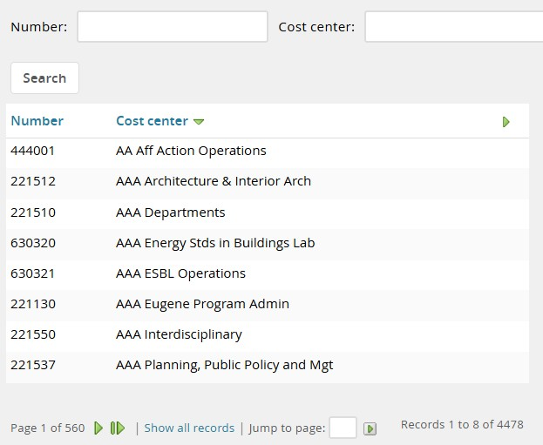
Type of Position  - Select the type of position.  - The position type will be finalized by UHR when the PD is approved. | 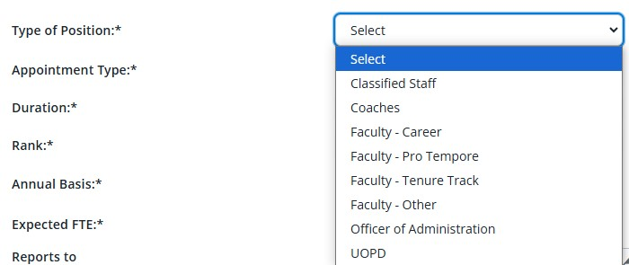
Appointment Type  - Select the Appointment Type from the available choices.  - Note that some appointment types are specific to certain employee groups. | 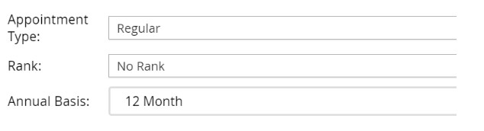
Duration  - Select the duration you expect for this position | 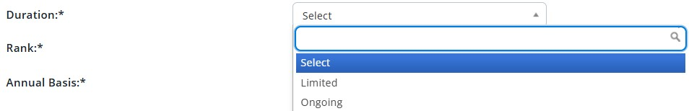
Rank  - Select the Rank for this position.  - For all non-faculty positions select “No Rank”.  - For faculty positions with multiple ranks, select the lowest rank possible for the position.  - You will confirm the rank for the successful candidate at the point of hire. | 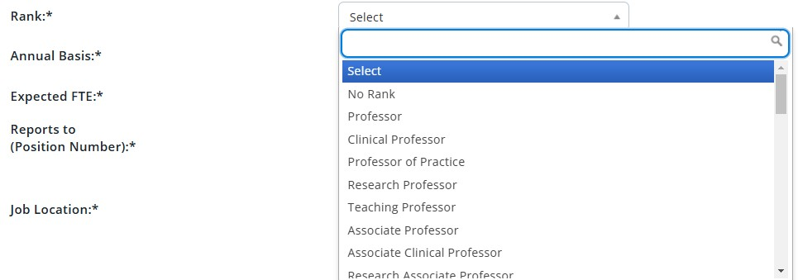
^Teaching Professor (ONLY) Level  - Make a selection in this field for teaching professors to note which level of courses they primarily teach. | 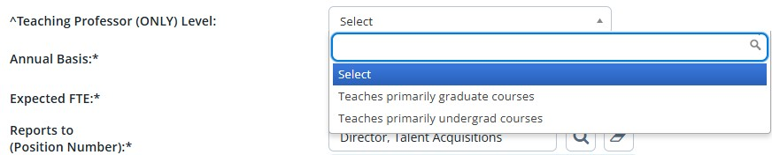
Annual Basis  - Select the annual basis for the position | 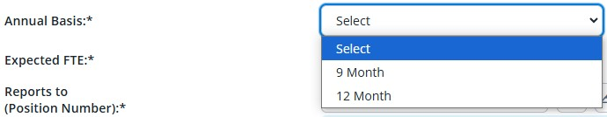

Expected FTE
- Enter the expected FTE for the position.
- Enter a number between 0.01 and 1.0.
- Do not enter letters in this field.
Reports to (Position Number)  - Enter the position number (B#) of the position that this position reports to.  - You may use the magnifying glass icon to open the search window.  - UHR recommends using Banner PWIVERI  - if you are having a difficult time finding the B# of the supervisor. | 
Primary Campus  (Eugene/Portland/Charleston)  - Enter the primary campus for the position, not the location of the employee  - Selection must be either Eugene, Portland, or Charleston | 

Position budget
Position Funding  - Select the funding source for this position.  - If the funding is not yet final, select the applicable ‘Requested’ option. | 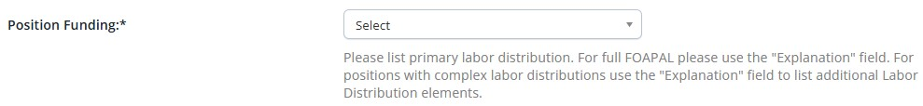
Labor Distribution  - This section provides information about the initial labor distribution of the position.  - Please give the primary labor distribution for this  position by listing index, account code, and percentage.  - For full FOAPAL elements  or a split labor distribution, use the “Explanation” field to list additional items (a secondary index, or a specific activity code). | 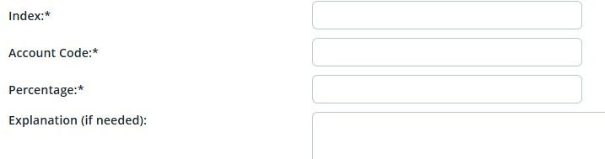

Position details
Organizational Chart  - Using the left side bar jump menu, click ‘Documents’ to open that section of the PD. You may need to use the scroll bar to scroll to show items at the bottom of the menu.  - From the drop-down menu, select “Document from a file”.  - Select “Org Chart” as the Document category.  - Title your Org Chart (optional).  - Click “Upload file” to browse for the file and select the file you would like to upload.  - Click “Submit and close”.  - To return to the Position Info section scroll back up the left jump menu and click that section header. | 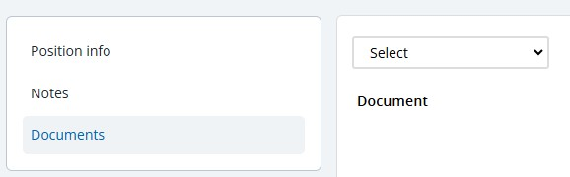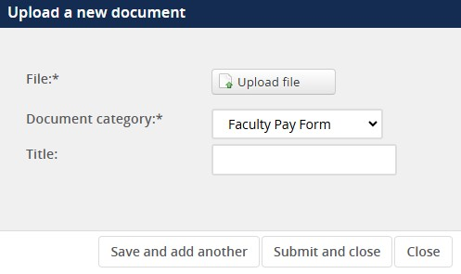

Summaries and Qualifications  - Each of these sections should be filled out completely.  - These fields will also be used to build out the job advertisement.  - For guidance on how to write summaries and define qualifications, visit our online resources. | 
Supervision
Supervisory Responsibilities  - Select the level of supervisory responsibilities for the position. For full  definitions, visit our online resources  - If multiple selections apply, select the highest level regularly performed. | 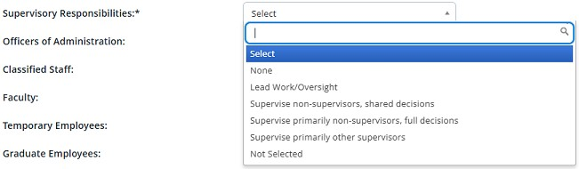

Employee Count  - Indicate the supervisory responsibility in FTE for this position against each employee category listed. | 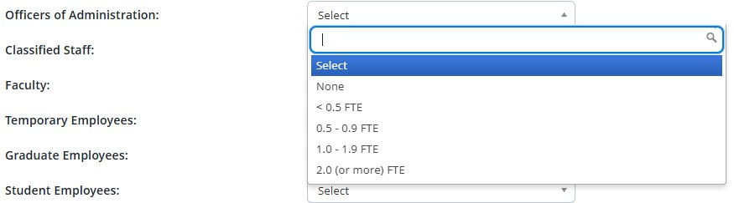
Decision making & fiscal responsibility
Scope of Decisions Made  - Select the appropriate choice from the drop-down menu that covers the scope of decisions that this position makes.  - Full definitions of menu items are available, visit our online resources. | 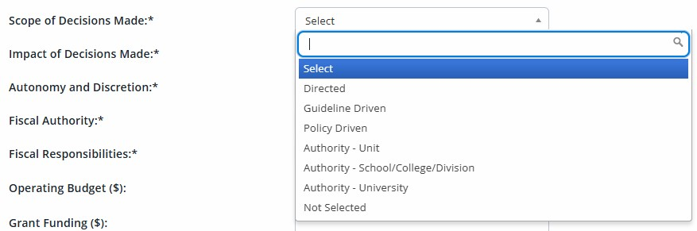

Impact of Decisions Made  - Select the appropriate choice from the drop-down menu that covers the impact of decisions that this position makes.  - Full definitions of menu items are available, visit our online resources. | 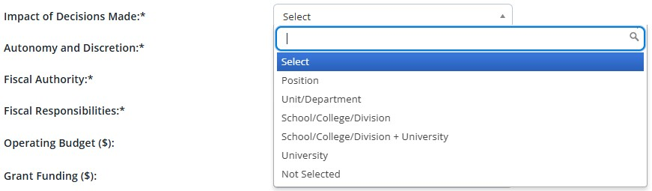
Autonomy and Discretion  - Select the appropriate choice from the drop-down menu that applies to this position.  - Full definitions of menu items are available, visit our online resources. | 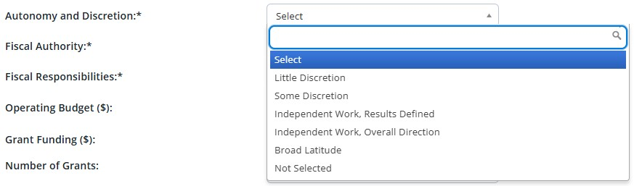
Fiscal Authority  - Select the appropriate choice from the drop-down menu that covers the scope of influence for this position.  - Full definitions of menu items are available, visit our online resources. | 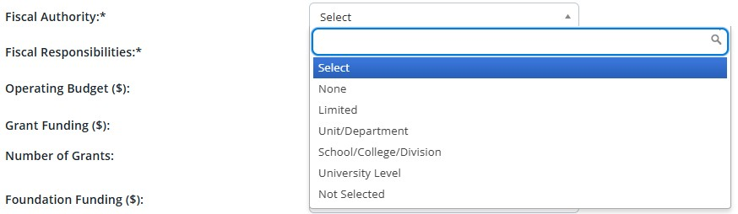

Fiscal Responsibilities  - Select the appropriate choice from the drop-down menu for this position.  - Full definitions of menu items are available, visit our online resources. | 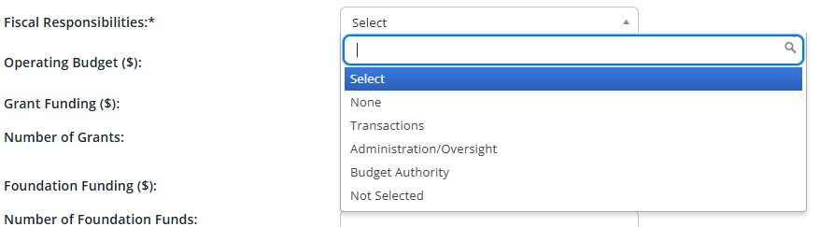
Budget Fields  - If the position has fiscal authority or responsibilities, enter the total operation budget. Depending on the position, this could include General, Auxiliary, Grant Foundation, and/or Agency funds.  - Grant funding, number of grants, foundation funds, number of foundation funds, and agency funding are optional fields.  - Fields labeled with $ should be in dollar amounts rounded as reasonable.  - Only list budget amounts that the position has fiscal authority or responsibility for. | 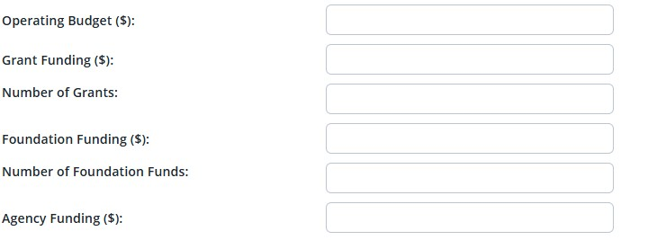

Job duties
Job Duties  - To enter a job duty, click “New”.  - Enter the percentage of time, duties/responsibilities, and then select whether he duty is essential or incidental.  - You must click “Add” to save the entry on the PD each time you enter a job duty.  - Confirm duties are complete and add up to 100% | 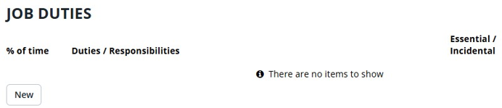

Working conditions
Typical Work Functions  - Check any applicable typical work functions | 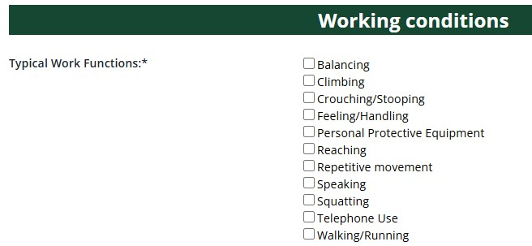

Typical Working Environment and Hazards  - Check any applicable typical working environment conditions or hazards.  - “Normal Office Environment”  is available for positions that work in a standard office. | 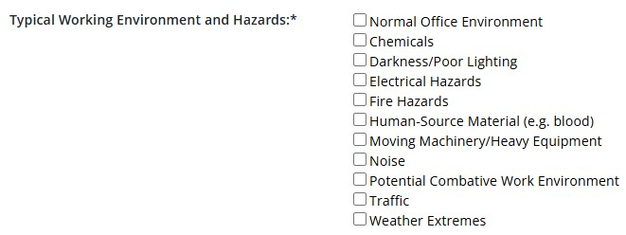
Lifting Demands  - Enter the lifting demands for this position.  - Minimum selection is “Up to 10 pounds”. | 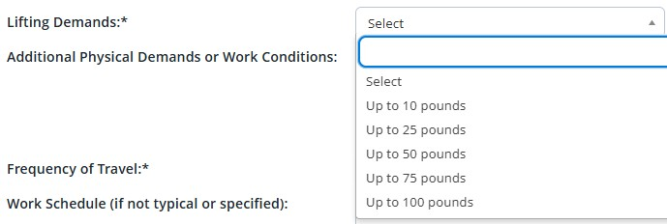
Additional Physical Demands or Work Conditions  - Enter any additional physical demands or work conditions not covered by the selections above. | 
Frequency of Travel  - Enter the percentage of time this position may be required to travel.  - Minimum selection is “Up to 10%”. | 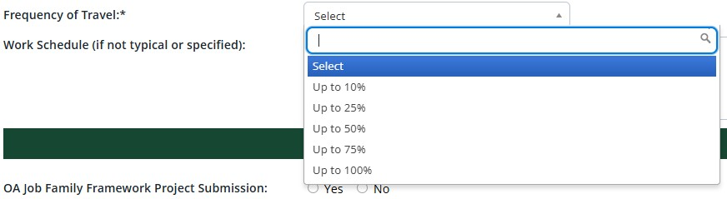
Work Schedule (if not typical or specified)  - Enter the work schedule if not typical. Typical is defined as 8 a.m. to 5 p.m.  - If a specific schedule is required as part of job duties, please note that here.  - A flexible work agreement may be required and can be uploaded to the system at the point of offer. | 

Human resources
Budget Profile  - This section is completed by UHR.  Coding  - This section is completed by UHR.  Salary, Bargaining Unit, & FLSA Status  - Completed by UHR as part of PD review.  - The salary range displays the approved range or comp band for the position.  - The range/band is visible in the blue box.  - UHR recommends review of this section after the PD has been approved.  Background Checks  - Completed by UHR as part of PD review.  - All positions require a criminal background check.  - Additional checks may be selected during PD review. | 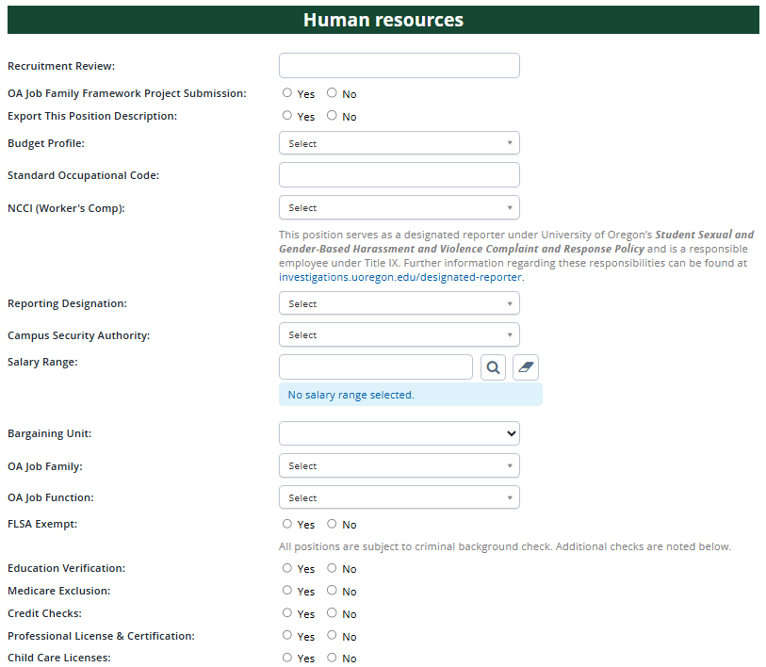

Users & approvals
User fields  - Enter your unit’s HR Administrator, the Hiring Manager for the position, and the Unit Director/Head in these fields.  - The Unit Director/Head field is located below the approval process drop-down menu.  - The Hiring Manager will default to the user who launched the PD. This can be changed by typing in the name of the correct individual or looking them up using the search function by clicking the magnifying glass icon.  - Users in these roles will receive an email when the PD is updated. | 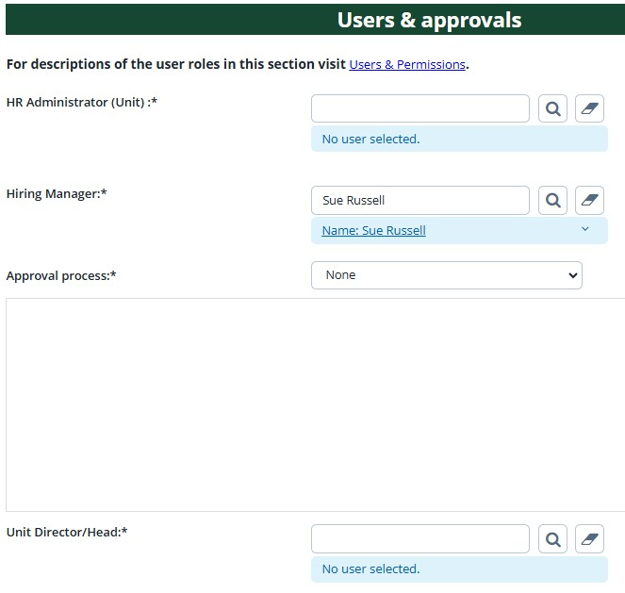

Approval Process  - Select the appropriate approval process.  - Use “Special Review Required” if a special reviewer or secondary unit needs to approve prior to submitting the PD to UHR for approval.  - Enter the appropriate approvers into the approver roles.  - The system will remember previous selections, you may need to edit prefilled approvers.  - Do no adjust UHR reviewer roles. | 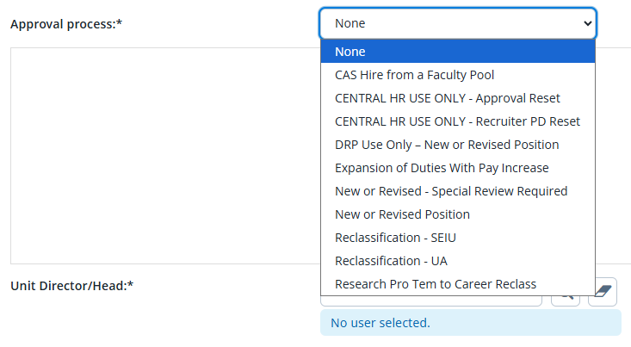

Finalizing the Position Description
Save a draft  - Can be used when you need to save the PD you are working on without yet starting the approval process. UHR recommends you save your work once per hour.  Submit  - This will save the PD and launch the approval process. You will remain in the PD after selecting this option. Submit and exit  - This will save the PD and launch the approval process and return you to the home screen.  Cancel  - This will exit the PD without saving. | 

Notes
- You can add additional information about the PD by scrolling down to the Notes section using the left jump menu and clicking on “Notes”  - From the “Add” drop-down field select “Note” and add the additional information using the text field in the pop-up window.  - Notes can be emailed directly to other users.  - You can upload files to your note.  - Notes are visible to anyone with edit access to the PD.  - Notes are retained through subsequent approval processes. | 