**Handshake ‘Job Description’ Section Template**

**The complete guide for posting a position on Handshake can be found** [**on the Employee and Labor Relations website**](https://hr.uoregon.edu/student-worker-hiring-and-job-posting)**. Please use the complete guide whenever posting a job on Handshake.**

**This template should be inserted in the ‘Job Description’ section of Handshake.** The ‘job description’ section is the first section of the Handshake posting. This template can be copied directly into the ‘job description’ field in Handshake.

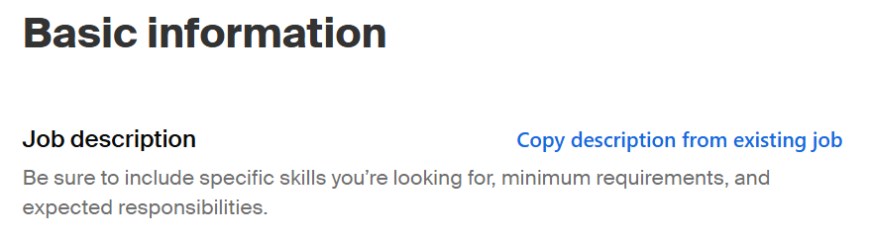

**Please note that this template was designed to ensure that the necessary information is included to comply with the UOSW Collective Bargaining Agreement (CBA).** Please be sure to complete all sections. If you make changes to the template, you must confirm it is still in compliance by consulting the Hiring and Job Postings article in the UOSW CBA. **Make sure you input the entire template in the ‘Job Description’ field, including the statements at the bottom.**

It is necessary to have a complete [position description](https://hr.uoregon.edu/student-worker-position-descriptions) before posting a job on Handshake.

**---------------------------------------BEGINNING OF TEMPLATE ----------------------------------------**

[**DENOTE CLEARLY HERE IF POSITION IS WORK-STUDY ONLY OR WORK-STUDY PREFERRED –** if not, delete this section]

**POSITION INFORMATION:**

Program Information

[COPY “PROGRAM INFORMATION” SECTION FROM POSITION DESCRIPTION]

Job Duties

[COPY “JOB DUTIES” SECTION FROM POSITION DESCRIPTION]

Minimum Qualifications

[COPY “MINIMUM QUALIFICATIONS” SECTION FROM POSITION DESCRIPTION]

Preferred Qualifications

[COPY “PREFERRED QUALIFICATIONS” SECTION FROM POSITION DESCRIPTION—if none, delete this section]

Scheduling Information

[INPUT SUMMARY OF SCHEDULING REQUIREMENTS—e.g. required hours/week, required shifts, hours of operation, etc.]

[CLEARLY DENOTE MANDATORY TRAININGS HERE]

Appointment Information

[INPUT SUMMARY OF APPOINTMENT INFORMATION—e.g. appointment end date, reappointment process, etc.]

[BACKGROUND CHECK REQUIRED?—If this position requires a background check, indicate that here. If not, delete this section]

**APPLICATION INFORMATION:**

[INPUT INFO ON APPLICATION INSTRUCTIONS HERE—if there is anything you would like to clarify about the application process, add that here. If not, delete this section.]  
  
For questions about this job posting, contact [INPUT NAME AND EMAIL].

*For full details on this position, please view the attached position description. Alternate formats of the position description are available upon request.*

* * * * * * * * * * * * * * *

The University of Oregon is an equal-opportunity institution committed to cultural diversity and compliance with the Americans with Disabilities Act. The University encourages all qualified individuals to apply and does not discriminate on the basis of any protected status, including veteran and disability status. The University is committed to providing reasonable accommodations to applicants and employees with disabilities. To request an accommodation in connection with the application process, please contact us at [uocareers@uoregon.edu](mailto:uocareers@uoregon.edu) or 541-346-5112.

UO prohibits discrimination on the basis of race, color, religion, national origin, sex, sexual orientation, gender identity, gender expression, pregnancy (including pregnancy-related conditions), age, physical or mental disability, genetic information (including family medical history), ancestry, familial status, citizenship, service in the uniformed services (as defined in federal and state law), veteran status, expunged juvenile record, and/or the use of leave protected by state or federal law in all programs, activities and employment practices as required by Title IX, other applicable laws, and policies. Retaliation is prohibited by UO policy. Questions may be referred to the Office of Investigations and Civil Rights Compliance. Contact information, related policies, and complaint procedures are listed [here](https://investigations.uoregon.edu/reporting).

Under the [Oregon Veterans' Preference in Employment](https://www.oregonlegislature.gov/bills_laws/ors/ors408.html), certain veterans may be eligible for employment preference - including for student positions. If you are a veteran or disabled veteran and would like to apply for the preference afforded under the Oregon Veterans' Preference statute for a student position, please email [talent@uoregon.edu](mailto:talent@uoregon.edu) by the application deadline or review date indicated in the position posting. We will provide you with a secure link to provide appropriate documentation (e.g. DD214, disabled veteran benefit letter). If you are eligible for the veterans' preference, the hiring departments will be notified of your status but will not be given access to your documentation. All eligible veterans are encouraged to apply for Oregon Veterans’ Preference.

**-------------------------------------------END OF TEMPLATE -------------------------------------------**